**PATFIN NURSERY AND PRIMARY SCHOOL, AKESAN, LAGOS STATE.**

**THIRD TERM EXAMINATION [ 2017 / 2018 ]**

**CLASS : K . G 2**

**NAME : ______________________________________ SUBJECT: BASIC SCIENCE**

**INSTRUCTION : ANSWER ALL QUESTIONS DURATION : 1 HOUR**

1. Fire is dangerous . [ Yes / No ]
2. Should you go to school on slippers? [ Yes / No ]
3. I must call for a helper when trying to cross the road [ Yes / No ]
4. Eating food from the floor can cause diseases [ Yes / No ]
5. Eating on the road is a good habit [ Yes / No ]

**PATFIN NURSERY AND PRIMARY SCHOOL, AKESAN, LAGOS STATE.**

**THIRD TERM EXAMINATION [ 2017 / 2018 ]**

**CLASS : K . G 2**

**NAME : ______________________________________ SUBJECT: BASIC SCIENCE**

**INSTRUCTION : ANSWER ALL QUESTIONS DURATION : 1 HOUR**

1. Fire is dangerous . [ Yes / No ]
2. Should you go to school on slippers? [ Yes / No ]
3. I must call for a helper when trying to cross the road [ Yes / No ]
4. Eating food from the floor can cause diseases [ Yes / No ]
5. Eating on the road is a good habit [ Yes / No ]

**PATFIN NURSERY AND PRIMARY SCHOOL, AKESAN, LAGOS STATE.**

**THIRD TERM EXAMINATION [ 2017 / 2018 ]**

**CLASS : K . G 2**

**NAME : ______________________________________ SUBJECT: SOCIAL – HABIT**

**INSTRUCTION : ANSWER ALL QUESTIONS DURATION : 1 HOUR**

1. Fasting and starving are the same [ True / False ]
2. An orphan has parents [ Yes / No ]
3. Walking about to sell something is called __________________. (a) Hawking (b) Blessing
4. Should you run away from house chores? [ Yes / No ]
5. Should your friends know you as a beggar? [ Yes / No ]

**PATFIN NURSERY AND PRIMARY SCHOOL, AKESAN, LAGOS STATE.**

**THIRD TERM EXAMINATION [ 2017 / 2018 ]**

**CLASS : K . G 2**

**NAME : ______________________________________ SUBJECT: SOCIAL – HABIT**

**INSTRUCTION : ANSWER ALL QUESTIONS DURATION : 1 HOUR**

1. Fasting and starving are the same [ True / False ]
2. An orphan has parents [ Yes / No ]
3. Walking about to sell something is called ______ (a) Hawking (b) Blessing
4. Should you run away from house chores? [ Yes / No ]
5. Should your friends know you as a beggar? [ Yes / No ]

**PATFIN NURSERY AND PRIMARY SCHOOL, AKESAN, LAGOS STATE.**

**THIRD TERM EXAMINATION [ 2017 / 2018 ]**

**CLASS : K . G 2**

**NAME : ______________________________________ SUBJECT: HEALTH – HABIT**

**INSTRUCTION : ANSWER ALL QUESTIONS DURATION : 1 HOUR**

1. I can hear with my ear [ Yes / No ]
2. _______ and ______ are parts of the body. (a) Hose and Shoe (b) Nose and Eyes
3. Is it healthy to dip your legs inside a muddy water [ Yes / No ]
4. Sponge and soap are items we use in bathing [ Yes / No ]
5. We must not litter the floor with biscuits and sweet [ True / False ]

**PATFIN NURSERY AND PRIMARY SCHOOL, AKESAN, LAGOS STATE.**

**THIRD TERM EXAMINATION [ 2017 / 2018 ]**

**CLASS : K . G 2**

**NAME : ______________________________________ SUBJECT: HEALTH – HABIT**

**INSTRUCTION : ANSWER ALL QUESTIONS DURATION : 1 HOUR**

1. I can hear with my ear [ Yes / No ]
2. _______ and ______ are parts of the body. (a) Hose and Shoe (b) Nose and Eyes
3. Is it healthy to dip your legs inside a muddy water [ Yes / No ]
4. Sponge and soap are items we use in bathing [ Yes / No ]
5. We must not litter the floor with biscuits and sweet [ True / False ]

**PATFIN NURSERY AND PRIMARY SCHOOL, AKESAN, LAGOS STATE.**

**THIRD TERM EXAMINATION [ 2017 / 2018 ]**

**CLASS : K . G 2**

**NAME : ______________________________________ SUBJECT: MORAL – INSTRUCTION**

**INSTRUCTION : ANSWER ALL QUESTIONS DURATION : 1 HOUR**

1. Can a stubborn child be humble? [ Yes / No ]
2. I must be happy all the time. [ Yes / No ]
3. Is it good to give to others generously. [ Yes / No ]
4. Disobedient children also have a reward. [ True / False}
5. _________ is the act of saying the truth always. (a) Honesty (b) Humility

**PATFIN NURSERY AND PRIMARY SCHOOL, AKESAN, LAGOS STATE.**

**THIRD TERM EXAMINATION [ 2017 / 2018 ]**

**CLASS : K . G 2**

**NAME : ______________________________________ SUBJECT: MORAL – INSTRUCTION**

**INSTRUCTION : ANSWER ALL QUESTIONS DURATION : 1 HOUR**

1. Can a stubborn child be humble? [ Yes / No ]
2. I must be happy all the time. [ Yes / No ]
3. Is it good to give to others generously. [ Yes / No ]
4. Disobedient children also have a reward. [ True / False}
5. _________ is the act of saying the truth always. (a) Honesty (b) Humility

**PATFIN NURSERY AND PRIMARY SCHOOL, AKESAN, LAGOS STATE.**

**THIRD TERM EXAMINATION [ 2017 / 2018 ]**

**CLASS : K . G 2**

**NAME : ______________________________________ SUBJECT: FOOD AND NUTRITION**

**INSTRUCTION : ANSWER CORRECTLY DURATION : 1 HOUR**

1. Do you need to wash your hands before you eat? [ True / False ]
2. ________ is a place where food is prepared (a) Bathroom (b) Kitchen
3. Should you eat unripe fruits? [ Yes / No ]
4. Any left – over food must be covered. [ True / False ]
5. Should you bathe in a bedroom? [ Yes / No ]

**PATFIN NURSERY AND PRIMARY SCHOOL, AKESAN, LAGOS STATE.**

**THIRD TERM EXAMINATION [ 2017 / 2018 ]**

**CLASS : K . G 2**

**NAME : ______________________________________ SUBJECT: FOOD AND NUTRITION**

**INSTRUCTION : ANSWER CORRECTLY DURATION : 1 HOUR**

1. Do you need to wash your hands before you eat? [ True / False ]
2. ________ is a place where food is prepared (a) Bathroom (b) Kitchen
3. Should you eat unripe fruits? [ Yes / No ]
4. Any left – over food must be covered [ True / False ]
5. Should you bathe in a bedroom? [ Yes / No ]

**PATFIN NURSERY AND PRIMARY SCHOOL, AKESAN, LAGOS STATE.**

**THIRD TERM EXAMINATION [ 2017 / 2018 ]**

**CLASS : K . G 2**

**NAME : ______________________________________ SUBJECT: C . R . S**

**INSTRUCTION : ANSWER CORRECTLY DURATION : 1 HOUR**

1. Is it good to mention the name of God in vain? [ Yes / No ]
2. Good children tell lies [ True / False ]
3. The followers of Jesus Christ are called ________. (a) Muslims (b) Groups (c) Christians
4. Does Jesus Christ always obey his heavenly father? [ Yes / No ]
5. God created living creatures that can move. [ True / False ]

**PATFIN NURSERY AND PRIMARY SCHOOL, AKESAN, LAGOS STATE.**

**THIRD TERM EXAMINATION [ 2017 / 2018 ]**

**CLASS : K . G 2**

**NAME : ______________________________________ SUBJECT: C . R . S**

**INSTRUCTION : ANSWER CORRECTLY DURATION : 1 HOUR**

1. Is it good to mention the name of God in vain? [ Yes / No ]
2. Good children tell lies [ True / False ]
3. The followers of Jesus Christ are called ________. (a) Muslims (b) Groups (c) Christians
4. Does Jesus Christ always obey his heavenly father? [ Yes / No ]
5. God created living creatures that can move. [ True / False ]

**PATFIN NURSERY AND PRIMARY SCHOOL, AKESAN, LAGOS STATE.**

**THIRD TERM EXAMINATION [ 2017 / 2018 ]**

**CLASS : K . G 2**

**NAME : ______________________________________ SUBJECT: K . O . W**

**INSTRUCTION : ANSWER CORRECTLY DURATION : 1 HOUR**

1. What is the name of your school?

____________________________________________________.

1. A rainbow has seven(7) colours . [ True / False ]
2. Television and radio are means of communication [ Yes / No ]
3. “All – back” and “Suku” are examples of hair styles girls can do [ True / False ]
4. Recite five(5) state and capitals.

**PATFIN NURSERY AND PRIMARY SCHOOL, AKESAN, LAGOS STATE.**

**THIRD TERM EXAMINATION [ 2017 / 2018 ]**

**CLASS : K . G 2**

**NAME : ______________________________________ SUBJECT: K . O . W**

**INSTRUCTION : ANSWER CORRECTLY DURATION : 1 HOUR**

1. What is the name of your school?

____________________________________________________.

1. A rainbow has seven(7) colours . [ True / False ]
2. Television and radio are means of communication. [ Yes / No ]
3. “All – back” and “Suku” are examples of hair styles girls can do [ True / False ]
4. Recite five(5) state and capitals

**PATFIN NURSERY AND PRIMARY SCHOOL, AKESAN, LAGOS STATE.**

**THIRD TERM EXAMINATION [ 2017 / 2018 ]**

**CLASS : K . G 2**

**NAME : ______________________________________ SUBJECT: P . H . E**

**INSTRUCTION : ANSWER ALL QUESTIONS DURATION : 1 HOUR**

1. Spin like a top [ 5 Times ]
2. Hop on one foot [ 5 Times ]
3. Run to the gate
4. Jump and clap [ 10 Times ]
5. Jog on a spot [ 10 Times ]

**PATFIN NURSERY AND PRIMARY SCHOOL, AKESAN, LAGOS STATE.**

**THIRD TERM EXAMINATION [ 2017 / 2018 ]**

**CLASS : K . G 2**

**NAME : ______________________________________ SUBJECT: RHYMES**

**INSTRUCTION : SING ALONG DURATION : 1 HOUR**

1. Cobbler ________ mend my _________

Get _________ done by ________ two

________ it __________ and ________ it down

Then I _______ you have a ________.

1. London bridge is ______ ________ falling _____ falling _________

My __________ lady

1. Tick say the ________ _______, _______,

What ________ have _________ do , do _______.

1. There are Seven rivers in __________, seven ________ in Africa

__________ Niger ________ Congo , Orange __________.

1. God’s ___________. God’s love is so wonderful so ____________ I can’t get _____________ so deep ____________ under it ____________ I can’t get around it ____________________.

**PATFIN NURSERY AND PRIMARY SCHOOL, AKESAN, LAGOS STATE.**

**THIRD TERM EXAMINATION [ 2017 / 2018 ]**

**CLASS : K . G 2**

**NAME : ______________________________________ SUBJECT: NUMBER – WORK**

**INSTRUCTION : ANSWER CORRECTLY DURATION : 1 HOUR**

1. Count and write numbers **100 – 150**

|  |  |  |  |  |  |  |  |  |  |
| --- | --- | --- | --- | --- | --- | --- | --- | --- | --- |
| 100 |  |  |  |  |  |  |  |  |  |
|  |  |  |  |  |  |  |  |  |  |
|  |  |  |  |  |  |  |  |  |  |
|  |  |  |  |  |  |  |  |  |  |
|  |  |  |  |  |  |  |  |  | 150 |

1. Fill in the gaps “**150 – 200** ”

**150** ______ 152 ____ 154 ____ 156 ____ 158 ____ 160 ______ 162 _____ 164 _____ 166 _____ 168 _____ **170** ______ 172 ____ 174 ____ 176 ____ 178 ____ **180** _____ 182 _____ 184 _____ 186 ____ 188 ____ 190 ____ 192 ____ 194 _____ 196 ____ 198 _____ **200**.

1. Addition of numbers
2. 3 + 2 = ______

◦◦◦ ◦◦

1. 5 + 3 = ________

◦◦◦◦◦ ◦◦◦

1. 2 + 2 = ________

◦◦ ◦◦

1. 4 + 4 = ___________

◦◦◦◦ ◦◦◦◦

1. 6 + 4 = ______________

◦◦◦◦◦◦ ◦◦◦◦

1. Fill the containers

 



Full Half Little

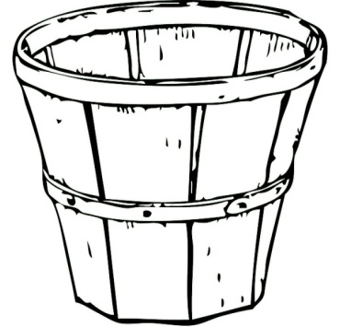 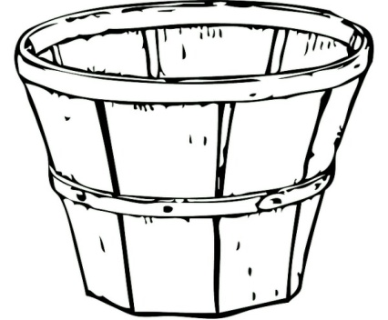

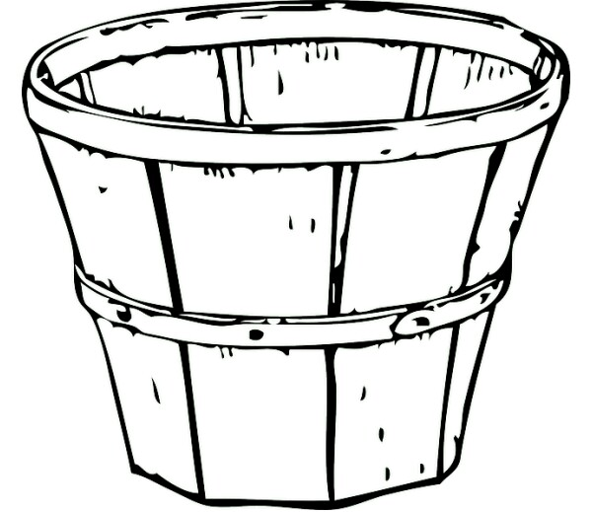

Little Half Full

1. Circle the larger objects

 





**PATFIN NURSERY AND PRIMARY SCHOOL, AKESAN, LAGOS STATE.**

**THIRD TERM EXAMINATION [ 2017 / 2018 ]**

**CLASS : K . G 2**

**NAME : ______________________________________ SUBJECT: LETTER – WORK**

**INSTRUCTION : ANSWER CORRECTLY DURATION : 1 HOUR**

1. Blending two(2) letter words with “i” and “o”

a m o f i s u p

______ _____ ______ ______

1. Fill in the gaps with the letters

Aa _____ Cc ____ Ee ____ Gg ____ Ii ____ Kk ___ Mm ____ Oo ____ Qq ____ Ss ____ Uu ____ Ww ____ Yy ____.

1. Read and copy simple sentences with two letter words

**It Is on**

____________

**Is It In?**

____________

**In It Is**

____________

1. Colour these shapes with primary colours
2. Read these simple sentences.
3. It is on
4. Is it on?
5. On it is.